PROJECT DESIGN PHASE
Proposed Solution

Date | 2 November 2025
Team ID | NM2025TMID08137
Project Name | Educational Organisation Using ServiceNow
Maximum Marks | 2 Marks

Proposed Solution Template:

S NO | Parameter | Description
1. | Problem Statement  (Problem to be solved) | Educational institutions often face challenges in handling large volumes of student and faculty data, admission processes, and performance tracking.  Manual record maintenance leads to inefficiency, errors, and communication gaps between  departments. A centralized digital solution is required to automate and streamline these administrative tasks.
2. | Idea / Solution Description | The project implements a ServiceNow-based  Educational Management System that automates key academic and administrative processes. It includes modules for student admissions, faculty data management, and progress tracking using ServiceNow features such as tables, forms, process  flows, and client scripts. The system provides a unified platform for managing all institutional

 |  | activities efficiently.
3. | Novelty / Uniqueness | The solution integrates educational operations within a single ServiceNow environment—  something traditionally used for ITSM. This creative repurposing of ServiceNow for academic  management demonstrates how enterprise automation tools can be applied beyond IT to improve educational workflows.
4. | Social Impact / Customer  Satisfaction | The system benefits students, parents, and faculty by offering transparent, real-time updates on admissions and performance. It reduces  administrative workload, improves data accuracy, and ensures smooth communication, contributing to a better educational experience for all stakeholders.
5. | Business Model (Revenue Model) | The solution can be deployed as a SaaS model for schools, colleges, and universities. Institutions adopting the system save on paperwork, reduce  delays, and enhance operational efficiency—leading to long-term cost savings and better resource  utilization.
6. | Scalability of the Solution | The platform can be extended to include additional modules like attendance tracking, course  management, or examination workflows. Its ServiceNow base makes it easy to scale for multiple institutions or integrate with third-party educational systems.

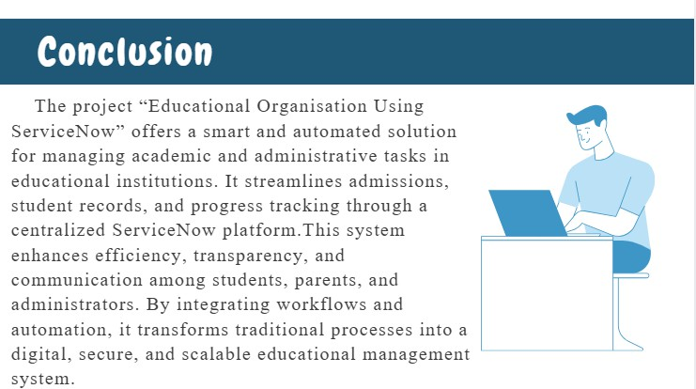

Reference: Infographic created using Canva.

Solution Description:
The “Educational Organization Using ServiceNow” project introduces a comprehensive, cloud-based digital platform that automates and streamlines the core academic and administrative operations of educational institutions.
The system architecture is designed to seamlessly integrate multiple modules, including the Admissions Management Table, Integration Layer, and ServiceNow Database, enabling smooth and secure data exchange among students, faculty, parents, and administrators.
Using ServiceNow’s automated workflows, the platform manages tasks such as admission tracking, record maintenance, approval routing, and notifications, ensuring faster processing and consistent updates. In addition, built-in analytics dashboards and security layers provide real-time insights, maintain data accuracy, and safeguard sensitive institutional information.
This solution empowers educational organizations to achieve higher efficiency, transparency, and reliability in their daily operations. By replacing manual processes with automation and centralized data management, institutions can transition toward a smart, digital ecosystem that promotes collaboration, accountability, and modern education management.

